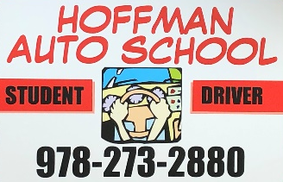
Hoffman Auto School
291 Main Street
West Newbury, MA 01985
978-273-2880

Student Registration Form

Today’s Date: _______________ Class Start Date Requesting: _______________

Student Information:

Last Name: ____________________ First Name: _______________ MI: ___

Street Address: _________________________________________________

City: __________________________ State: _______ Zip: ____________

Male □ Female □ Other □

Home Phone: ______________________ Student Cell:__________________

Parent Cell: ______________________ Student Email: ________________

Date of Birth: ______________________ Age: ____ Years ____ Months

High School: ______________________ Town: _______________________

(If applicable) Permit # ___________________ Date Issued: _________________

Additional Questions:

Do you wear corrective lenses for Driving? _____

Do you have any physical condition that requires special Driving Equipment in the car? ______

Do you have any special learning needs? ______ Do you take medication regularly? ______

Have you ever been convicted of a crime or had the privilege of driving suspended, revoked or otherwise limited by the RMV? ________

How Did you Hear About Us? _________________________ Promo Code: ____________

Please explain any Yes answers here: ___________________________________________________________________________________________________________________________________________________________________________________________________________________________

Applicant Signature: ___________________________________ Date: ________________

Please send in with an initial deposit of at least $300.00 to hold seat in class.

